Task 1: XCHG

; You may customize this and other start-up templates;

; The location of this template is c:\emu8086\inc\0_com_template.txt

; add your code here

.model small

.stack 100h

.code

main proc

mov bl,'A'

mov cl,'B'

xchg bl,cl

mov ah,02

mov dl,bl

int 21h

mov ah,02

mov dl,cl

int 21h

mov ah,4ch

int 21h

main endp

end main

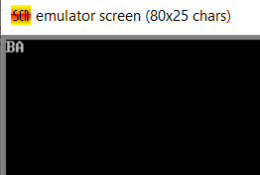

Task 2: getting input

; You may customize this and other start-up templates;

; The location of this template is c:\emu8086\inc\0_com_template.txt

; add your code here

.model small

.stack 100h

.code

main proc

mov ah,01

int 21h

mov ah,02

mov dl,al

int 21h

mov ah,4ch

int 21h

main endp

end main

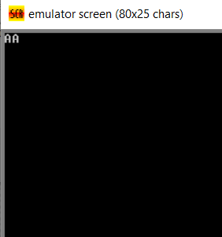

Task 3: Newline carriage return

; You may customize this and other start-up templates;

; The location of this template is c:\emu8086\inc\0_com_template.txt

; add your code here

.model small

.stack 100h

.code

main proc

mov ah,01

int 21h

mov bl,al

mov ah,02

mov dl,0dh

int 21h

mov dl,0ah

int 21h

mov ah,02

mov dl,bl

int 21h

mov ah,4ch

int 21h

main endp

end main

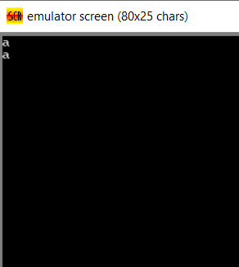

Task 4: take input and then exchange and then display on new line

; You may customize this and other start-up templates;

; The location of this template is c:\emu8086\inc\0_com_template.txt

; add your code here

.model small

.stack 100h

.code

main proc

mov ah,01

int 21h

mov bl,al

mov ah,01

int 21h

mov cl,al

xchg bl,cl

mov ah,02

mov dl,0dh

int 21h

mov dl,0ah

int 21h

mov ah,02

mov dl,bl

int 21h

mov ah,02

mov dl,cl

int 21h

mov ah,4ch

int 21h

main endp

end main

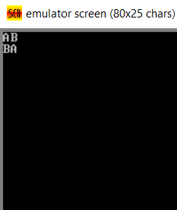

Task 5: print university using variables

; You may customize this and other start-up templates;

; The location of this template is c:\emu8086\inc\0_com_template.txt

; add your code here

.model small

.stack 100h

.data

var1 db ?

var2 db ?

var3 db ?

var4 db ?

var5 db ?

var6 db ?

var7 db ?

var8 db ?

var9 db ?

var10 db ?

.code

main proc

mov ah,01

int 21h

mov var1,al

mov ah,01

int 21h

mov var2,al

mov ah,01

int 21h

mov var3,al

mov ah,01

int 21h

mov var4,al

mov ah,01

int 21h

mov var5,al

mov ah,01

int 21h

mov var6,al

mov ah,01

int 21h

mov var7,al

mov ah,01

int 21h

mov var8,al

mov ah,01

int 21h

mov var9,al

mov ah,01

int 21h

mov var10,al

mov ah,02

mov dl,0dh

int 21h

mov dl,0ah

int 21h

mov ah,02

mov dl,var1

int 21h

mov ah,02

mov dl,var2

int 21h

mov ah,02

mov dl,var3

int 21h

mov ah,02

mov dl,var4

int 21h

mov ah,02

mov dl,var5

int 21h

mov ah,02

mov dl,var6

int 21h

mov ah,02

mov dl,var7

int 21h

mov ah,02

mov dl,var8

int 21h

mov ah,02

mov dl,var9

int 21h

mov ah,02

mov dl,var10

int 21h

mov ah,4ch

int 21h

main endp

end main

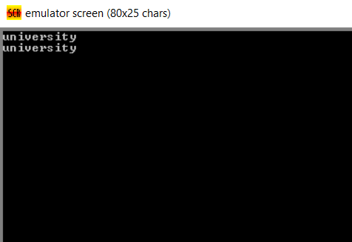

Task 6: display next character

; You may customize this and other start-up templates;

; The location of this template is c:\emu8086\inc\0_com_template.txt

; add your code here

.model small

.stack 100h

.data

var1 db ?

var2 db ?

var3 db ?

var4 db ?

var5 db ?

var6 db ?

var7 db ?

var8 db ?

var9 db ?

var10 db ?

.code

main proc

mov ah,01

int 21h

mov bl,al

inc bl

mov ah,02

mov dl,bl

int 21h

mov ah,4ch

int 21h

main endp

end main

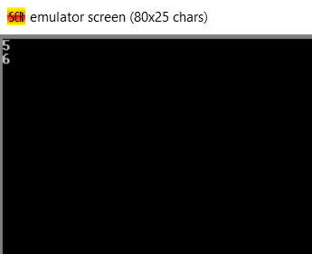

Task 6: display previous

; You may customize this and other start-up templates;

; The location of this template is c:\emu8086\inc\0_com_template.txt

; add your code here

.model small

.stack 100h

.data

var1 db ?

var2 db ?

var3 db ?

var4 db ?

var5 db ?

var6 db ?

var7 db ?

var8 db ?

var9 db ?

var10 db ?

.code

main proc

mov ah,01

int 21h

mov bl,al

dec bl

mov ah,02

mov dl,0dh

int 21h

mov dl,0ah

int 21h

mov ah,02

mov dl,bl

int 21h

mov ah,4ch

int 21h

main endp

end main

